Cloud Computing

**Name:** Jerusha Angel K

**Register No**: 727721EUCS049

Day-6

**Day 6_VPC_CE1**

**Content Description:**

Create a vpc with multiple subnets(atleast 1 subnet in each zone)

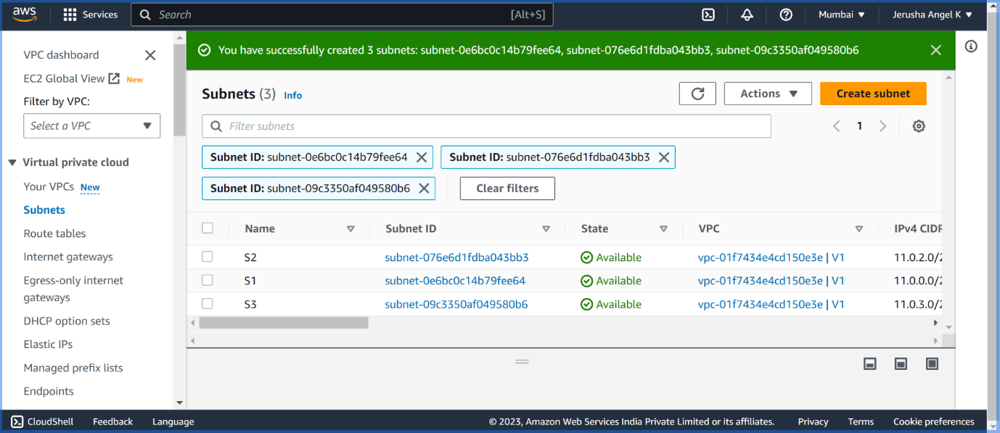

**Day 6_VPC_CE2**

**Content Description:**

Make 1 public subnet and 2 private subnets in the created VPC

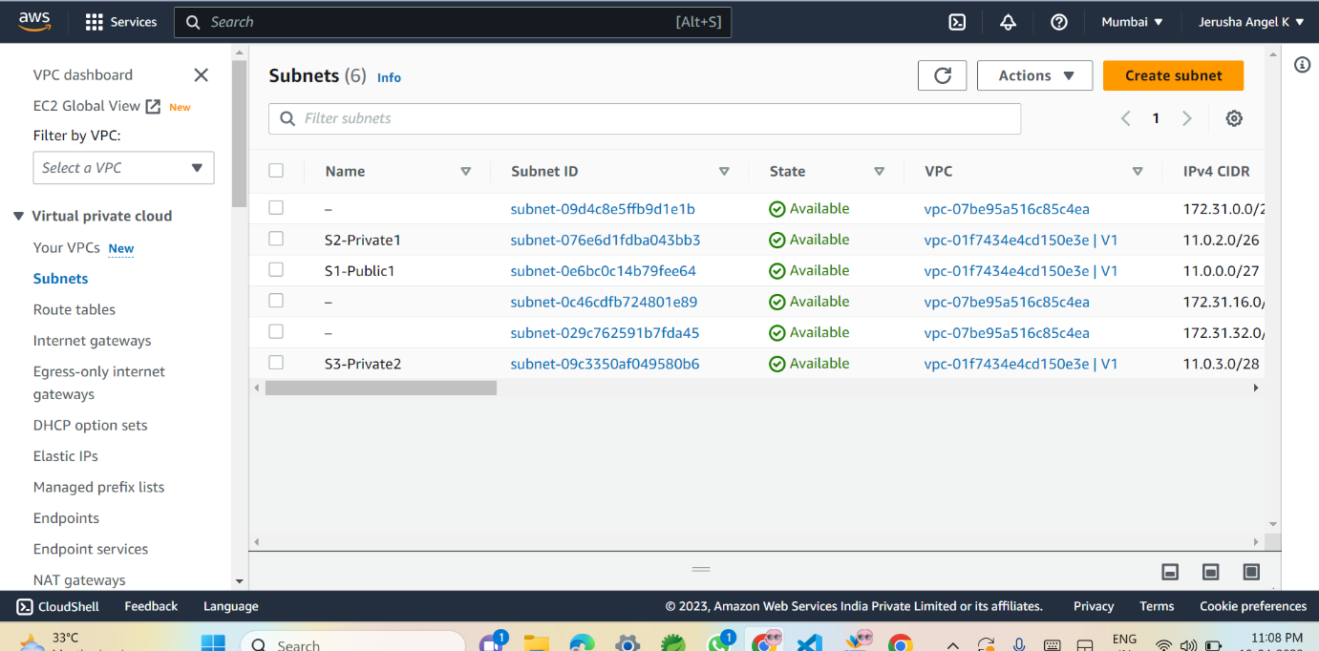

**Day 6_VPC_CE3**

**Content Description:**

Make internet connection using NAT gateway for the 2 private subnets.

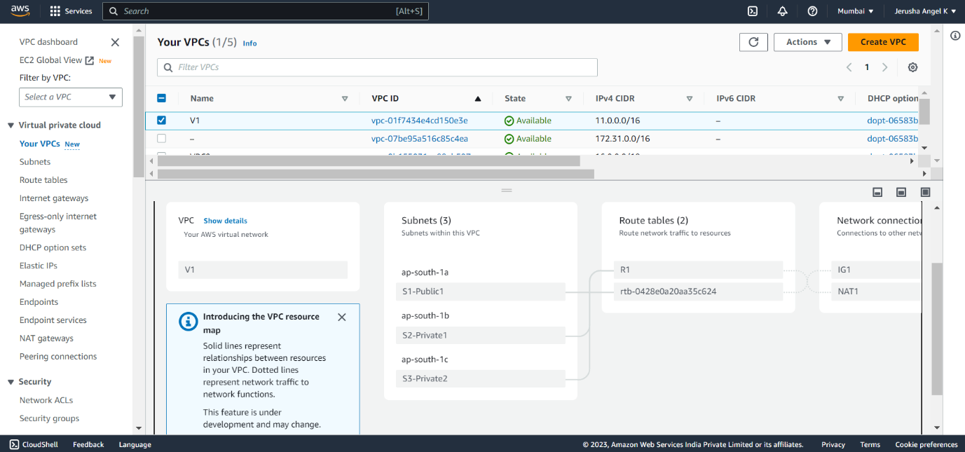

**Day 6_VPC_CE4**

**Content Description:**

Create a VPC peering connection between 2 different VPCs from 2 different regions.

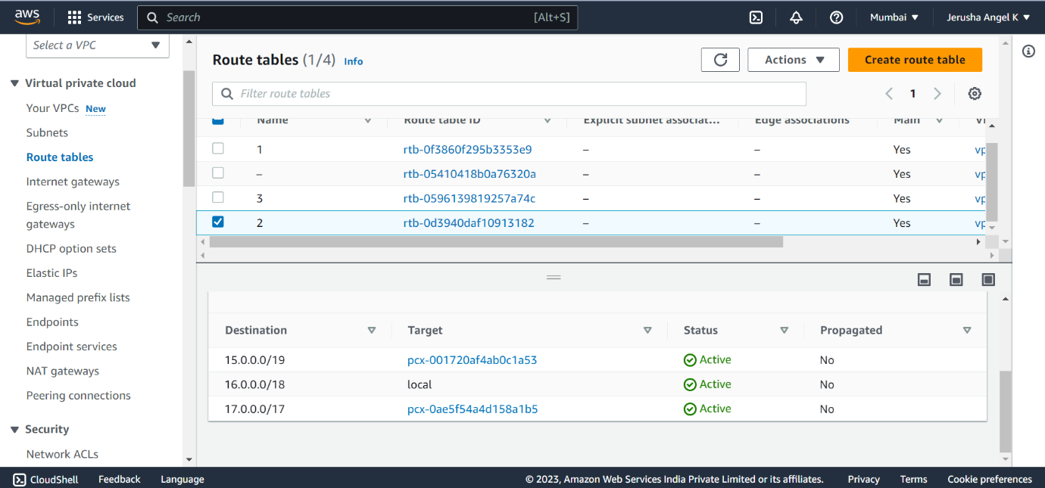

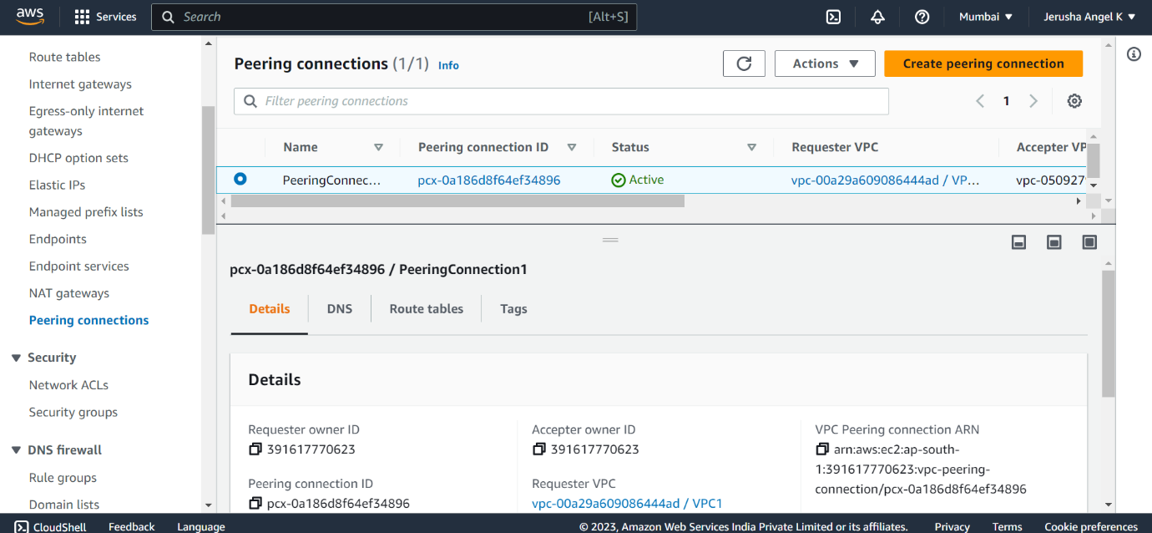

**Day 6_VPC_CE5**

**Content Description:**

Create VPC peering connections for 3 different VPCs from the same region



**Day 6_VPC_CE6**

**Content Description:**

Add security rules in the VPC's NACL which should deny RDP, SSH from the public network

